Department Activity 2015-16
S.No | Date | Name of the Activity
1 | 22-09-2015 | Extension lecture
2 | 17-11-2015 | Student seminar
3 | 19-11-2015 | Student seminar
4 | 20-11-2015 | Quiz
5 | 20-11-2015 | Student seminar
6 | 28-11-2015 | Group Discussion
7 | 04-12-2015 | ppt
8 | 19-12-2015 | Field visit
9 | 20-02-16 | Field trip to LIC office
10 | 20-02-16 | Field visit to Head post office(chirala):

S No | Date | ACTIVITY REPORT & PHOTO Activities 2019-2020
1 | 22-09-2015 | Extension lecture:D.JohnRaj lecturer in Economics Y.A.Govt Degree college for women chirala delivered a Extension lecture on “12th five year plan” to III B.A students of D.S Govt Degree college for women, Ongole.  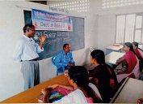
2 | 17-11-2015 | Student seminar:N.sriravamma,III B.A student presented a student seminar on “Poverty”.  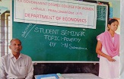
3 | 19-11-2015 | Student seminar:P.V.Parvathi,I B.A student presented a student seminar on “Markets”.  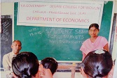
4 | 20-11-2015 | Quiz:A Quiz competition was conducted on National income to II B.A students.  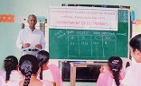
5 | 20-11-2015 | Student seminar:M.Parimala,II B.A student Presented a student seminar on”Measurement of National Income”.  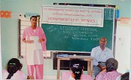
6 | 28-11-2015 | Group Discussion:A Group Discussion was conducted on:Prices-Rise and Fall to I B.A students.  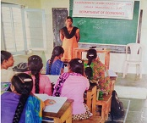
7 | 04-12-2015 | ppt:A Powe point presentation on “five year plans”to III B.A students.  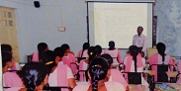
8 | 19-12-2015 | Field visit: B.A students visited the V.R.S&Y.R.N college chirala to see the Exhibition organized by the institution.  1.B.A students visited the college library  2.visited the Exhibition stalls and viewing the “water harvesting model”  3.visited the dept. Economics and interacted with the staff and students.  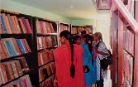  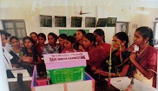  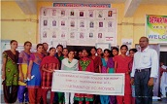
9 | 20-02-16 | Field trip to LIC office: visited the LIC office and interacted with the branch manager.  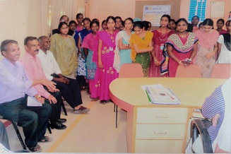
10 | 20-02-16 | Field visit to Head post office(chirala):B.A students visited the post office and interacted with the staff and the customers.  